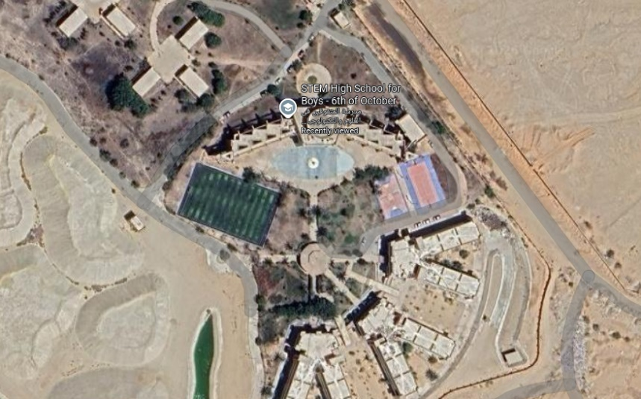
The real-life application of this prototype is recommended to be constructed in STEM High School for boys - 6th of October, which is shown in figure 1, as it is suitable due to its environmental conditions for our project. It will utilize an integrated cooling system similar to the prototype with the exception of the water spray mechanism being integrated behind the fans themselves. The heating system will utilize the same concept with more spacious heating coils. The rest of the system will remain largely as is. In terms of dimensions, it will follow a scale of 1:10, the height would be 7 meters, and two square bases of segments 5 meters each.
Figure 1

